# 

# Handout: Ask, Build, Check – building health literacy skills and knowledge

**Overview of Ask, Build, Check**

**Ask: This is the most important step and easiest to do**

*“Tell me what you know/think/ believe/do …”*

**Build: You are already doing some of this**

Build new information onto what people already know.

At the end of Step 2& before you move onto Step 3 ask *“Most people have lots of questions. What are your questions?”*

*This way you can add & clarify new information before you move onto checking you have been clear.*

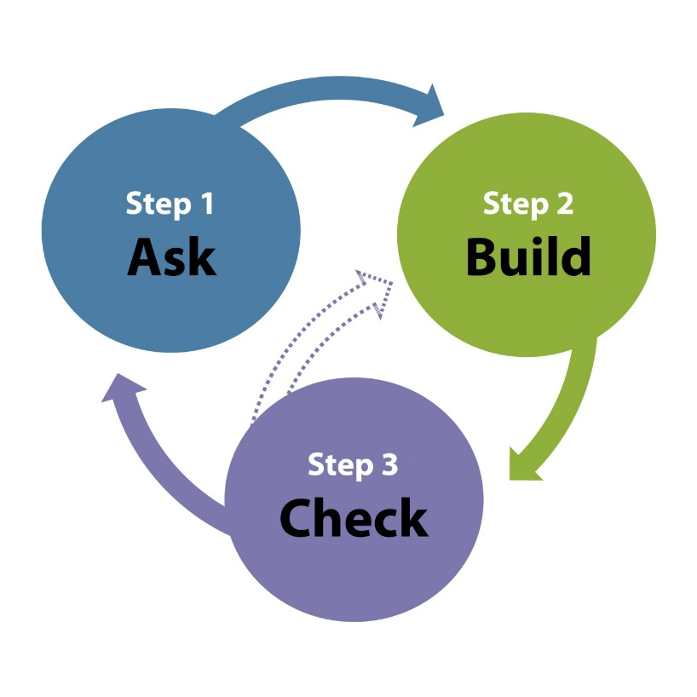

**Check: This is the hardest step and needs lots of practice**

*“I want to check I’ve been clear. What are you going to do when you get home?”*

*“I want to check I’ve been clear. What are you going to say to your partner?”*

## Step 1: Ask (find out what people know, think, do and believe)

This is the most important part of the Three Step Model. Every person you work with has existing knowledge and beliefs, even if those beliefs and knowledge are incorrect.

Step 1 helps:

##### you uncover what people already know, think, do and believe

##### you plan how much information you will give people and in what order in Step 2

###### people recall what they already know so they can make connections to the new information you give them.

When you are talking to people, listen to what the person tells you and acknowledge what they know.

Also listen to the words the person is using. For example, if they say they have “runny poos” this shows they either don't know or are not confident to use the word diarrhoea. So, use the words they used "*You said you have runny poos*” and later you can say “*Have you ever heard the word diarrhoea? It's a hard word to say and even harder to spell. Well it means just what you said - runny poos.*"

Sometimes people will have incorrect knowledge or beliefs about their health condition. To add new correct information, you are going to have to deal with that incorrect knowledge in a way that recognises the person may have held these beliefs for a long time and that there are very valid reasons for those beliefs. If you just add new information without addressing the incorrect beliefs, the person may reject the new information because it doesn’t fit with what they already know.

So, if someone says to you:

“*I get gout because I eat too much seafood.*”

You could say:

*“A lot of people think when they eat seafood they get a gout attack. We have a lot more information now that gout is about how your kidneys get rid of uric acid and this is often affected by your genes. Some people have genes which mean their body produces too much uric acid and some people have genes which mean their kidneys don't get rid of enough uric acid."*

### Setting an agenda

During Step 1 it is useful to ask the person the things they want to discuss. For example, *"Today I would like to find out how you are feeling and then talk about how you are getting on with the goals on your care plan. What would you like to talk about? Okay I will write that down. What else is worrying you? Okay I have written that down - anything else?"*

Keep asking questions until the person says they don't have anything else to talk about. Then show the person the list and say *“Which ones do you want to talk about first?"*

### Basis for Step 1 - prior knowledge

Finding out what people know is the most important step. If you don’t find out what people know at the beginning, but just give them new information, they could easily reject that new information if it doesn’t make sense with what they already know. They might be able to repeat the information back to you (Step 3) but will still not act on it because the information hasn’t been linked to what the person already knows.

Everyone has prior knowledge about their health. This is the basis for Step 1. Sometimes people know a lot and what they know is correct. Other times people don’t know very much or what they know isn’t quite correct.

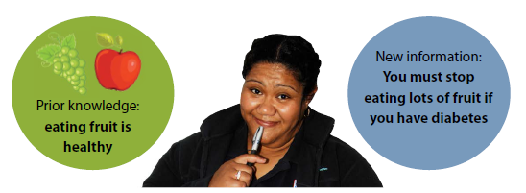

Everyone has been in the situation where someone has told you something you already know. Sometimes you feel frustrated or you get distracted because you think *“I know this already”*.

We have also been in the situation where someone has told us something and it makes no sense in relation to what we already know so we reject the new information.

If you find out what people know, you can then add new information to their prior knowledge. This might mean you don’t have to say very much at all in Step 2. People feel good when they have their prior knowledge validated.

If people have incorrect beliefs or knowledge, these can be addressed in Step 2.

|  |  |
| --- | --- |
| **Tips for finding out what people know** | Ask these questions at the beginning in a friendly tone. The tone you use is important because suddenly asking someone to tell you everything they know about something can seem threatening and may put some people off.  Try putting the words “***Tell me****”* in front of any questions you ask e.g. *“Tell me what you know about what could happen next”.* This signals to the person that you are not expecting a very short answer.  *“Tell me what you know about your kidney disease.”*  Or you could prompt the person by saying “*Did anyone say anything about having to go on dialysis?”*  This helps the person remember something in their short-term or long-term memory.  *“Have you ever used or heard about this medicine before?”*  *“What did they say about your cough?”* |

## Step 2: Build (people’s health literacy to meet their needs)

Health professionals are already using Step 2 with people.

**Remember, link all new information back to what the person knows at Step 1. Use the words the person used and build on these words.**

“*So, you said when you eat seafood you get gout. This is because eating seafood makes a lot of uric acid in your body. If you have too much uric acid in your body, your genes stop your kidneys getting rid of uric acid and so it turns into very painful crystals in your joints.*”

Building new skills and knowledge involves the co-construction of knowledge between you and the person you are working with. You need to think about the agenda you worked out with the person and what information is essential for the person. You will not be able to cover everything. And if you do try to give the person all the information you think they need you will end up overloading the person’s short-term memory. And the person may not remember anything you talked about including the important information you gave them in the first place.

### Ask permission

"*Is it okay if we talk about the fact that you haven’t had a smear for the last 10 years?*" And if it isn't say "*That's okay, I will make a note of it here and will ask you again hwne I see you next in case you have changed your mind*.”

### Always explain why

People need to know why they have to do something. Knowing why means people are more likely to carry out the action because they understand its importance.

**Welcome different points of view:** It is okay if people want to do something different from what you think is best for them. Listen really carefully to understand their reasons for doing something different.

Trying to persuade the person to make the change you think is best will only work while the person is sitting in front of you. Afterwards they will not be able to recall your reasons for wanting them to make a change. And remember it is not your job to motivate the person. Your job is to help the person work out what motivates them.

**Understand people make their own decisions about changing behaviour:** This is linked to the previous point. You want people to tell you what they are doing rather than pretending that they are doing something you want them to do. Accept that it is okay if sometimes people don’t feel motivated to change their behaviour or they have other more pressing things going on in their lives. Ask them what is important to them.

**Acknowledge where people are at:** Sometimes, just telling you their story is enough for the person. They are not at the stage where they can make any changes. Acknowledge that and say you will follow up. *“It sounds like you have got too much on at the moment. How about I ring you in two weeks and see how you are going?”* Or *“I understand you don’t want to make a change at this time. Is it okay if I check in with you from time to time in case you have changed your mind?”*

Follow up in a few days when the person may have had time to think about what they want to do. Be prepared to follow up again if they are still not sure.

**Believe people can create their own solutions:** Asking people what they think will work for them is the best approach. They know their own situation and what they can manage at this timer. Always resist telling people what they need to do – it doesn’t work. And remember to affirm what people are doing right.

**Be non-judgmental:** This is linked to cultural competence and your biases. People have their own reasons for doing things. These reasons can be seen as illogical and unreasonable from your perspective.

People are very quick to pick up when you don’t think they are doing the right thing. Being non-judgmental means finding out the reasons why the person wants to do something so you can understand their perspective and what they want to do as a result. Remember you are not questioning whether their reasons are valid for that person

**Strategies you can use at Build Step**

The strategies you use at this step will depend on what information you want to give, what will work best for the person, the time you and the person have, the resources you have and what the person wants to know.

Here are some strategies we think you might already be using at this step.

1. **Giving information in logical** **steps** e.g. when you are explaining how to use a blood glucose meter or inhaler.
2. **Giving information in chunks** 3-5 pieces of information so people don’t get overloaded.
3. **Explaining technical words –** people need to hear and read a new word 40 times before it becomes part of their vocabulary.
4. **Using apps, visuals and/or written resources.**
5. **Help people to anticipate the next steps** – *“If you don’t feel better in 2 days, come back”.*
6. **Reinforce and emphasise** *“It is really important that you …”*.

|  |  |
| --- | --- |
| **Tips for building new information and skills** | Make sure you link new information to what people already know.If the information is complex, check you have been clear after each chunk (Step 3) before going onto the next chunk.Link the words you use to the words the person used in Step 1 Ask – if they say ‘high blood pressure’ use that term, not ‘hypertension’. Later, if you think it is relevant, you can explain that high blood pressure means the same thing as hypertension.Monitor the language you use – don’t use technical terms unless you know the person knows them.  * Try and use plain English words and explain key medical words, particularly if the person needs to know those words. * Repeat new vocabulary. People don’t learn new words just by hearing them once. * Write down new words or underline or highlight them in written material. Write down how you say them. * Ask questions such as *“Did anyone explain what the word haemodialysis means?”*  Choose visuals that concentrate on the main messageWhere possible, use colour pictures and diagrams.Label diagrams with new technical words.Tell people what to expect when taking a new medicine e.g. side effects.  * Tell people when they need to contact you again e.g. no improvement. * Tell people if they may need to be referred for extra help, for example, a podiatrist e.g*. “If your feet don’t improve we will refer you to a podiatrist who can help you. You will get a phone call to make an appointment.”* |

## Step 3: Check (you were clear)

This is the step that gets overlooked because you run out of time. Or else you use questions such as *“Do you have any questions?*”, “*Does that make sense?”* or *“Do you understand?”* as a way of checking people have understood. Asking closed questions like these is not effective to find out if you have been clear. People are most likely to say they don’t have any questions and they do understand, even when they don’t because they are concerned you might think they are stupid

The responsibility for effective communication is on you as the person giving the information. So, Step 3 isn’t a test of how well the person has understood you. Instead Step 3 is about how clearly and effectively you communicated.

Checking you have been clear is about getting feedback from the person you have been talking to about how clear your communication was.

If you do not check you have been clear, the only indication that the person did not understand may be a medicine error or failure to follow up. Relying on spoken, non-spoken and non-verbal cues such as the person saying *“yes”* or nodding is not accurate.

If you use Step 3 (check you have been clear) and find that you weren’t clear and the person does not recall information given previously, think about what you said that wasn’t clear. Was there a problem with the language you used or did you give too much information the first time? Or perhaps the person was stressed or feeling unwell.

If you weren’t clear the first time, simply repeating what you said won’t work. Instead find another way of rephrasing or restating the information, maybe using visual reminders to help the person. For example:

*“How about I write it down as 1... 2... 3.”*

*“Would it help if I wrote it down for you?”*

*“I think this diagram/picture will help explain what we have been saying is going on in your body."*

In the USA, checking understanding is called ‘teach-back’ or ‘teach to goal’ because you are asking the person to ‘teach-back’ to you what you have just discussed with them.

##### Focus on becoming confident at using Steps 1 and 2, Ask and Build before you start using Step 3 Check

##### Some people working in health find Step 3 difficult to use at first so try using it at the beginning or the end of the day.

##### Develop a ‘script’ that works for you

##### Practise with a colleague.

##### Once you have used Step 3, think about what you did well and what you could improve next time.

##### Talk to colleagues about what they are finding useful.

* Explain to the person you are working with that you are trying something new.

|  |  |
| --- | --- |
| **Tips for checking you have been clear** | Ask the person to repeat, in their own words, what they now know or need to do. For example: *“I want to check I have been clear, so can you tell me what you have to do and I will listen to make sure I explained it properly.”*  *“Just to be sure I haven’t missed something can you tell me what I have told you about how to take this medicine?"* Take responsibility for not being clear e.g. “*Sorry I haven’t been clear – what do you think would help you to remember this information?*”Use prompts if the person has only missed out a small piece of information e.g. “*Do you remember what we said about weighing yourself to check if you are retaining fluid?*”Use pictures and diagrams when people haven’t understood spoken information or instructions.Link it back to what the person knows e.g. "*You told me you sometimes feel you are retaining fluid because your shoes get too tight. We want to find out about it before that happens so ....*"Make sure it is obvious to the person that you are taking responsibility for being clear. “*It is my responsibility to be clear when talking with you. I didn’t do such a good job just then. Let’s go over that again.”* |