Self-Management Support Training Module: Using written and other resources with people with long-term conditions

Learning objectives for this session
By the end of this session participants will be able to:
- describe how resources are selected, ordered, stored and used in their practice with people with long-term conditions (LTCs)
- identify a written resource they use with people with LTCs
- describe a process for using a written resource or visuals with a person with LTCs
- familiarise themselves with resources and apps.

Trainer’s Notes
1. Please read this document and the Handout at least a couple of days before the training session. And remember you can adjust this Training Plan. For example, if your practice already has a well-established process for ordering and storing resources you could skip that activity and spend more time looking at resources your staff use with people with LTCs.
2. Before you deliver this workshop, you need to think about written resources in your practice – who chooses them, who orders them, where they are stored, how often they are checked in terms of how current they are and how relevant they are to people with LTCs. Have a look at how resources are displayed in your waiting or reception area.
3. Have a look at the list of resources attached to this training plan. See if there are any resources that you don’t have copies of in your practice or get someone else from your staff to check the list for new appropriate resources.
4. Please print off enough copies of the Handout for the number of participants in the session.
5. Collect a range of Heart Foundation resources you use in your practice with people with LTCs and take these to the training session.
6 Ask a couple of staff who will be coming to the session to bring to the session a resource the participants use a lot with people with LTCs..
7. You will need to have a laptop or laptops with internet access to show the apps library on the Health Navigator website.
8. Please have a whiteboard or flipchart available and enough post-its so each participant has three post-its for the evaluation activity.
9. Complete the Certificate of Attendance on the last page of this Training Plan for each participant.

Purpose and time | Activity
Welcome everyone to the session.
Explain that in this session you are going to discuss the written resources that you use with people with LTCs in your practice, and different ways you can use resources as well as apps that might be useful for people with LTCs.
Activating prior knowledge  (15 mins) | Using resources with people with LTCs in your practice  Explain that the purpose of this part of the session is to find out what participants know about how resources are selected and ordered for your practice, where resources are stored, who staff tell when stocks are running low and who checks resources and throws out those that are not current. .  If participants don’t know, write up the process on a whiteboard or a flipchart. Here is an example.  1. Staff member identifies a new resource.  2. Staff member gets it approved by person who manages resources (e.g. nurse leader, practice manager).  3. Admin person orders resource.  4. When resource arrives, admin person puts it in resource cupboard.  5. At next nurses meeting, staff member demonstrates new resource. Where relevant, nurses agree it will replace existing resource.  6. Admin person checks resources for re-ordering each week (re-order when five resources left).  If there is time in this part of the session go out and look at the resources displayed in the reception or waiting area in your practice.
Building new knowledge  (15 mins) | How do you use written resources with people with LTCs?  Ask of the participants who agreed earlier to demonstrate how they use written resources with people with LTCs.  Ask them to tell you:  - what the resource is  - why they are giving the resource  - what they want the person to do as a result of reading the resource.  After the two participants have finished, give everyone a copy of the Handout and go through the tips on the first page. Acknowledge where the two participants did a good job.  Discuss with participants if they think it is better to have a few key resources participants use repeatedly with people with LTCs (e.g. cholesterol resources, COPD resources) rather than lots of different resources.
Building new knowledge  (15 mins) | Using visuals  Ask participants if they think about people’s reading skills when selecting resources for people with LTCs. One way of supporting people who may not think they are good at reading is to choose resources with visuals.  Ask participants how many of them brought resources with visuals to the session. Hand out some Heart Foundation resources and point out that the Heart Foundation usually have short resources with a small amount of text and good visuals which link to the text.  Ask participants if they use separate visuals (not included in a resource) or draw pictures for people or use models such as models of knees, heart or spine. Make a list of visuals participants use.  Then go through the tips for using visuals on page 2 of the Handout.
Building new knowledge  (10 mins) | Using apps with people with LTCs  Show the Health Navigator apps library: www.healthnavigator.org.nz/apps/a/app-library/  Ask participants if they use apps with patients or use the Health Navigator apps library.  If any participants have used the app library before, get them to briefly talk about an app and why they chose the app.  Quickly go through the app library and explain how the rating (star) system works – rated by a range of experts. Explain that apps are really useful self-management tools for all age groups. Quickly look at the range of apps.  Point out to participants that there is a section on page 2 of the Handout about using apps.
Evaluation  (5 mins) | Plus, Minus and Interesting Plus, Minus and Interesting  Make sure everyone has access to post-it notes. Ask everyone to take three post-it notes – label the first one ‘P’ (for plus), the second ‘M’ (for minus) and the third ‘I’ (for interesting).  Explain this is an evaluation of the session.  Ask people to write something on each of their three post-its (what was a plus, what was a minus and what was interesting) and then put the post-its up on a wall/whiteboard/table top under the three categories.  Take a photo of the responses for your records.

Certificate of Attendance

Please complete the certificate on the last page of this Training Plan for each of the participants.

Resource list
Also see www.healthnavigator.org.nz/ for more information and resources and relevant Health Coach notes for specific conditions.
Resource title and information
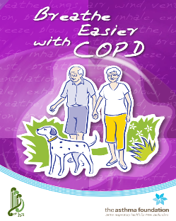 | Breathe Easier with COPD  32 pages  Free to print  The Asthma Foundation  https://s3-ap-southeast-2.amazonaws.com/assets.asthmafoundation.org.nz/documents/Breathe-Easier-with-COPD-Resource.pdf
Local  Respiratory Services | Ask your local respiratory services provider about the resources that they use for their patients with COPD  Find out about the local pulmonary rehabilitation or Better Breathing Programmes available locally and how to refer to them.
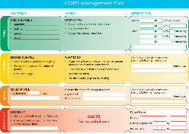 | COPD Management Plan – emergency action plan  1 page  Free to print  The Asthma Foundation  https://s3-ap-southeast-2.amazonaws.com/assets.asthmafoundation.org.nz/documents/COPD-Management-Plan-Resource.pdf
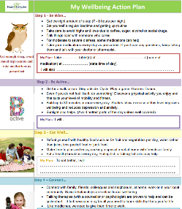 | My Wellbeing Action Plan – depression  2 pages  Free to print  Health Navigator NZ  https://www.healthnavigator.org.nz/media/1004/depression-action-plan-draft-v-10-july-2013.pdf
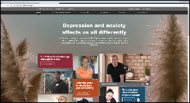 | Depression.org.nz  - Free online service for New Zealanders. It includes other people’s stories of living with depression, The Journal online help service and lots more information and tips. Also includes the Lowdown site for teens. https://depression.org.nz/
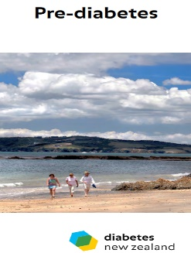 | Pre-Diabetes  2 pages  Free to download  Diabetes New Zealand  Order copies from https://diabetes.org.nz/resources-and-publications__trashed/pamphlet-order-form/  Charge applies
Local  Diabetes  Service | Ask your local diabetes services provider about the resources that they use for their patients with diabetes  Find out about the local diabetes self-management education programmes available locally and how to refer to them.
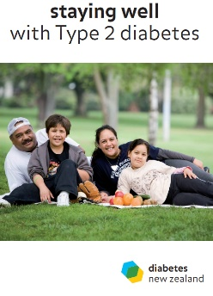 | Staying Well with Type 2 Diabetes  24 pages  Free to download  Diabetes New Zealand  Order copies from https://diabetes.org.nz/resources-and-publications__trashed/pamphlet-order-form/  Charge applies
Diabetes and Healthy Food Choices
24 pages
Free to download
Diabetes New Zealand
Order copies from https://diabetes.org.nz/resources-and-publications__trashed/pamphlet-order-form/
Charge applies
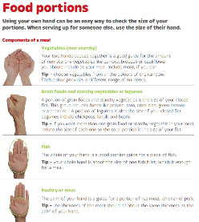 | Food Portions  2 pages  Free for first 25  Heart Foundation  https://www.heartfoundation.org.nz/resources
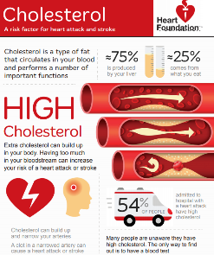 | Cholesterol  2 pages  Free for first 50 - available in different languages  Heart Foundation  https://www.heartfoundation.org.nz/resources
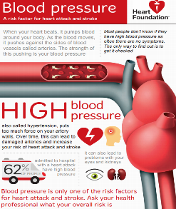 | Blood Pressure  2 pages  Free for first 50 - available in different languages  Heart Foundation  https://www.heartfoundation.org.nz/resources
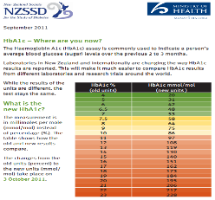 | HbA1c – Where are you now?  2 pages  Free to print  Ministry of Health  https://www.healthnavigator.org.nz/media/1001/hba1c-diabetes-flyer.pdf
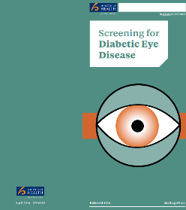 | Screening for Diabetic Eye Disease  2 pages  Free to print  Ministry of Health  http://www.health.govt.nz/system/files/documents/publications/screening-for-diabetic-eye-disease_resource_for_people_who_have_been_referred_for_screening.pdf  or download order form
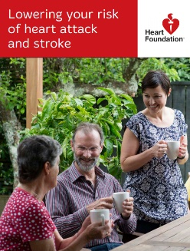 | Lowering Your Risk of Heart Attack and Stroke  24-page booklet  Free for first 25  Heart Foundation  https://www.heartfoundation.org.nz/resources
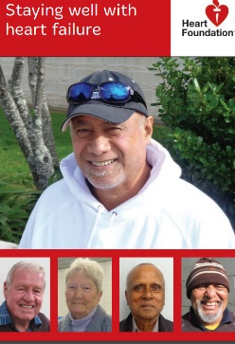 | Staying Well with Heart Failure  48-page booklet  Free for first 25  Heart Foundation  https://www.heartfoundation.org.nz/resources
Local Cardiology services | Ask your local Cardiology services provider about the resources that they use for their patients with heart failure  Find out about the local cardiac rehabilitation available locally and how to refer to them.
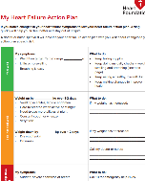 | Heart Failure Action Plan and Daily Checks  4 pages  Free to download http://assets.heartfoundation.org.nz/shop/heart-healthcare/non-stock-resources/my-heart-failure-action-plan.pdf
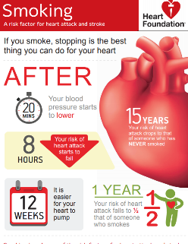 | Quit Smoking  2 pages  Free for first 50 - available in different languages  Heart Foundation  https://www.heartfoundation.org.nz/resources
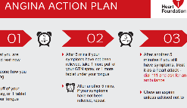 | Angina Action Plan  1 page  Free to download and print http://assets.heartfoundation.org.nz/shop/marketing/non-stock-resources/angina-action-plan.pdf
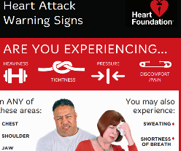 | Heart Attack Warning Signs  1 page  Free for first 25  Heart Foundation  https://www.heartfoundation.org.nz/resources
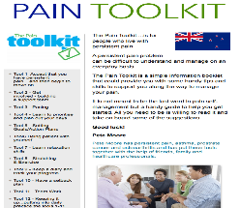 | Pain Toolkit  24 pages  Free to download  Pete Moore @ pain toolkit  https://www.paintoolkit.org/images/uploads/downloads/Pain_Toolkit_New_Zealand.pdf
Stop Gout
12-page booklet can be printed A4 or A5 from the attached PDF
http://www.health.govt.nz/system/files/documents/topic_sheets/stop_gout_booklet-dec2015.pdf

Healthy Lifestyle  General | Good quality free resources can be obtained from  Health Promotion Agency to download and print free on A4 or order free A3 posters  http://nutritionandactivity.govt.nz/nutrition  Vegetables.co.nz have good recipe ideas and healthy eating resources with a vegetable focus  http://www.vegetables.co.nz/education-and-resources/order-prints

