Goal Setting and Action Planning training module (1 hour)

Learning objectives for this training workshop

By the end of this session participants will be able to:

- Explain what goal setting and action planning are and how they support behaviour change for people with long-term conditions (LTCs)
- Describe the difference between behavioural goals and healthcare team/outcome goals
- Describe how to assess importance and confidence in relation to achieving a goal
- Complete goal setting and action plans
- Describe the reasons why ‘pacing’ is important
- Describe ways to record and monitor goals and action plans and why this is important
- Describe some ways of monitoring and recording action plans and goals.

Trainers notes

- Please read this document and the Handout at least a couple of days before the training session.
- Allow one hour to deliver this training session. If refreshments are being served as part of this session or it is linked to another meeting or activity, ensure that you allow enough extra time for this.
- Please print off enough copies of the Handout depending on the number of people in the session. If you decide to show the video/s you will need to have a laptop with internet access to show the video during the session
- Have a whiteboard or flipchart and marker pens available to record ideas during the brainstorming session.
- Develop some examples of case studies from your own practice if you want to use them instead of the case studies in the Handout. Make sure your case studies cover off all the items in Action Plan.
- For the evaluation activity have one post it note for each participant.

Purpose and topic | Activity | Resources
Welcome everyone to the session
Explain that in this section participants will learn about and practise goal setting and action planning skills.
Activating prior knowledge | Goal setting and action planning  Brainstorm the question below with the participants. Record participants’’ responses on a flipchart of white board. Keep these responses as you may need to refer to them later in the session.  - What do you think goal setting and action planning is?  - Keep asking questions about the purpose of GS and AP and how they can help people with LTCs.  If there is time briefly ask a couple of participants about their experience.  Give participants a copy of the Handout. Refer participants to page 1 and point out any information not covered in the brainstorm and link to additional information participants identified in the brainstorm. | Page 1 of handout  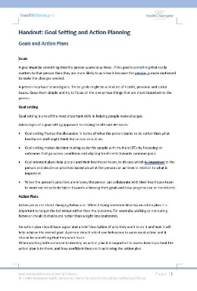
Building new knowledge | Differences between patient and healthcare goals, and behavioural and outcome goals  Get participants to go to page 2 of the Handout. Get participants to work in pairs on the top section of page 2 and work out whether the goal is a patient goal or clinician goal. Say to participants you need to be able to explain why you made that decision. Quickly go around the group and find out what each pair decided and why.  Possible answers are 1. Patient 2. Patient 3 Clinician 4. Clinician 5. Clinician. 6. Patient although you could argue either way with some goals e.g. Goal 4 could be a patient goal for a smoker who has pre diabetes.  If participants have little experience and/or have found this activity difficult then write up key message below on whiteboard and get them to copy onto their own Handout.  Key messages  Important that:  - the goal is what the person with LTCs wants to do  - you understand the person’s motivation to change and where possible include it in the goal e.g. Goal 2 .  Then ask participants to look at the bottom part of page 2 – the difference between behaviour goals and outcome goals.  Give participants a couple of minutes to read this part of the page and then talk about the differences between behavioural and outcome goals. Reinforce that all goals are behavioural (require change). However, behaviour goals state the behaviour the person is going to do. And outcome goals just state the outcome and the underlying behaviour is not stated.  Get participants to look at the goals at the top of the page – ask participants if they can identify which goals include the stated outcome .(Only Goal 2 about going to library)  Ask participants what they notice between the two types of goals – how would having the outcome stated in the goal help the health care staff member/person with LTCs. Remind participants that it is always important for both the person and the health care staff member to know the person’s motivation to understand why the person is changing their behaviour. For health care staff it is also a useful thing to check from time to time with the person that this is still their motivation in case something else has become more important to the person.  Again, if you need to, reinforce key messages below by saying I just want to check I have been clear can someone please explain the differences between a behavioural goal and an outcome goal.  Key messages  - Behavioural goals –must be something that the person wants to do and important to the person. The best behavioural goal statement should contain the motivation for change. A person should only be working towards one behavioural goal at a time and the goal should be simple and easily achievable in the first instance.  - Outcome goals –These are usually clinical in nature such as reduction in blood pressure, weight, HbA1c etc. They are generally achieved as a result of a change in behaviour. For example, a reduction in blood pressure (outcome) as a result of regular exercise (behavioural). | Page 2 of handout  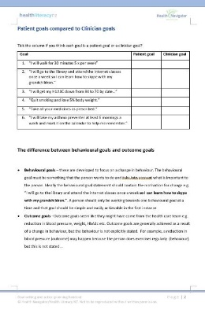
Building new knowledge | Change ruler –assessing importance and confidence  Refer participants to page 3 of the Handout and give them a couple of minutes to read it.  Ask the group, who has used a change ruler when talking to people about changing behaviour?  If necessary explain that the change ruler measures two things – importance and confidence in slightly different but important ways.  Ask participants why they think it is important to measure importance and confidence?  Depending on experience in the group either you explain or get someone in the group to explain how the ruler is used to measure importance of a change to a person ( the participant can refer to the relevant part of page 3). Ask the participant who is explaining if they can think of a personal example from people the participant has worked with.  Once the participant has finished emphasise the importance of the backwards question. Use Goal 2 on page 2 as an example. So, if you ask the person how important this is to them on a scale of 1 to 10 and they say 7 you then ask them a backwards question in terms of the number – why are you are at 7 and not a 5. The person is likely to give you lots more information about their reasons for change e.g. I had a really good grandmother who was very loving, who listened to me and believed in me and taught me lots of things and I want to try and be like that for my grandchildren  Make sure you write down any additional information as this is extra information about the person‘s motivation and might be useful if the person later finds it hard to achieve their goal.  Model with the participants what could happen if you had asked a forward question e.g. why are you at a 7 and not a 9. The person might say well I can still talk to them over the phone at the moment so it might not be that urgent after all and I am not very good at using the computer so it is going to take a log time so maybe it isn’t that important.  And the person might be puzzled by your question – Are you suggesting that I should be doing this more quickly, do you think I won’t achieve my goal?  Remember your role is to support people to achieve the goal that is important to them not to undermine the goal and make the person feel uncertain.  Repeat the process for confidence. You only need to ask questions if the person’s confidence level is less than a 7. Point out that the process for confidence is the opposite of importance. With confidence you use a forwards question. Get a participant to explain how to assess confidence with an example goal or else use one of the goals on page 2. Remind participants to look at the relevant part of page 3. The point of asking the confidence question is that research has shown people need to be at 7 in terms of confidence to achieve their goal.  Point out to participants that they don’t have to remember all this. Take a copy of the ruler on page 3 and write on it – backwards for importance and forwards for confidence (if not already a 7) | Page 3 of the handout  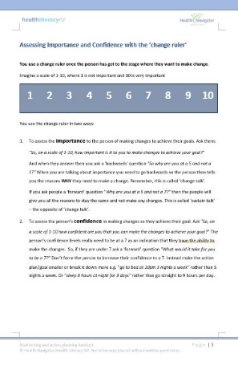
Building new knowledge | Developing an action plan using a case study  Refer participants to pages 4 and 5. Explain page 5 is a blank Action Plan. Quickly go through the Action Plan. Ask participants to work in pairs to fill in the action plan on page 5 using the case study on page 4. Explain that all the information they need is the case study. Give participants 5- 10 minutes to do this depending on their levels of experience. Afterwards have a general discussion about how they went, what they notice about the action plans, how this action plan differs from one they are used to. Look at the completed action plans to make sure they are accurate. .  Key messages:  - Action plans are about changing behaviour. When helping someone develop an action plan it is important to focus on the behaviour rather than the outcome. For example, walking or not eating between meals (behaviours) rather than weight loss (outcome).  - An action plan should include a goal that is SMARTER – write this on a whiteboard (specific, measurable, actionable, relevant, timebound, able to be evaluated and readjusted). The good news is that using the Action Plan form ensures that the person has a SMARTER goal. If necessary go through the Action Plan to show where each of SMARTER acronym applies.  - Remind that a person with LTCs should select one behaviour to work on at a time and it should be something that they want to do.  - Remember to use the change ruler (page 3) to assess how important a goal is to the person, and how confident they are in achieving the goal in the action plan.  - Importance of social support – who is going to support them to achieve their goal and carry out their action plan  - It is ok for the person to identify the things they are not ready to do at the time of completing the action plan. This is often a big relief to people and gives them an opportunity to be successful  Pacing  Plan to avoid doing too much and address any barriers  refer participants to page 6 of the Handout and give them a few minutes to read it.  Key messages:  - If people suddenly become more active than they have previously, it can result in injury or the symptoms of the person’s long-term conditions getting worse. People can end up in more pain and more fatigued than they were before.  - Important to talk about this when you are completing an action plan (how much, how often) so people can be realistic. Also need to talk about what they can do if for example it is raining, and they can’t go outside – what could the person do instead.  Ask the participants to write these ideas down on the plan. | Pages 4, 5 and 6 of the handout  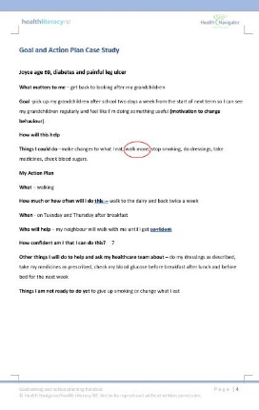  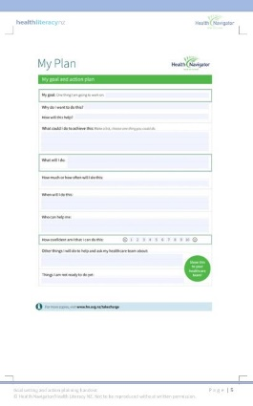  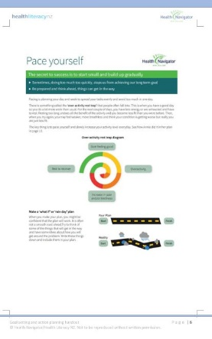
Building new knowledge | More case studies and action plans  Refer participants to pages 7 and 8 and get them to choose a case study and complete the action plan on page 9. If you have time get the participants to do the other case study or use case studies from your own practice. At the end have a quick discussion about how participants found the exercise this time.  Key messages  People who write down and share their goals and action plans are 70% more likely to achieve their goals than when goals are not written down and shared.  Things you can suggest to people  - Put the action plan in a prominent place at home e.g. on the fridge  - Reinforce the importance of having a ‘support team’.  - Encourage people to monitor progress (a diary or Keeping on Track worksheets in Take Charge workbook if people are using it or standalone pages that can be downloaded from the website https://www.smstoolkit.nz/take-charge)  Have a quick discussion with participants to get their ideas and experiences of supporting self-monitoring and useful tools such as apps. | Pages 7 and 8 of the handout  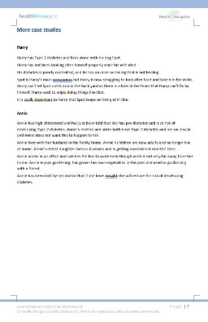  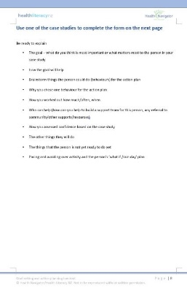
Checking you have been clear | Evaluation  Say to participants there are at least 12 key points about Goal setting and action plans. Write Key Points up on the whiteboard  Go around the participants and see if they can identify the key points. Make sure everyone participates.  Key points include:  - Goal must be important to person  - Include behaviour not just outcome  - Action Plan supports behaviour change  - SMARTER (key points in the Action Plan)  - Assess importance  - Assess confidence  - Plan for what ifs and rain day  - Avoid overactivity trap  - Support team  - Write action plan down  - Share action plan  - Monitor progress towards goal  Ask participants to write down on a post it note one thing they are going to do differently as a result of this session. Take a photo of the post it notes for your records so you can follow up with participants.  Thank participants for taking part in the session.

