Structured problem-solving module

Overview
We all face problems in life and structured problem solving is a proven approach that many people have found helpful for working through difficult problems no matter what it is. As a health professional this is a simple yet effective tool that you can use yourself and teach your patients.

Learning objective
Describe the structured problem-solving technique and to be able to use it effectively with clients.

Facilitator notes
- This short module should take 15 minutes to deliver.
- Prepare the handouts depending on the number of people attending the session.
- There is an optional video that describes the structured problem solving process. It takes 9 minutes and can be shown at the end of the session if time allows.
- Video can be accessed here https://www.healthnavigator.org.nz/videos/s/self-management/structured-problem-solving/

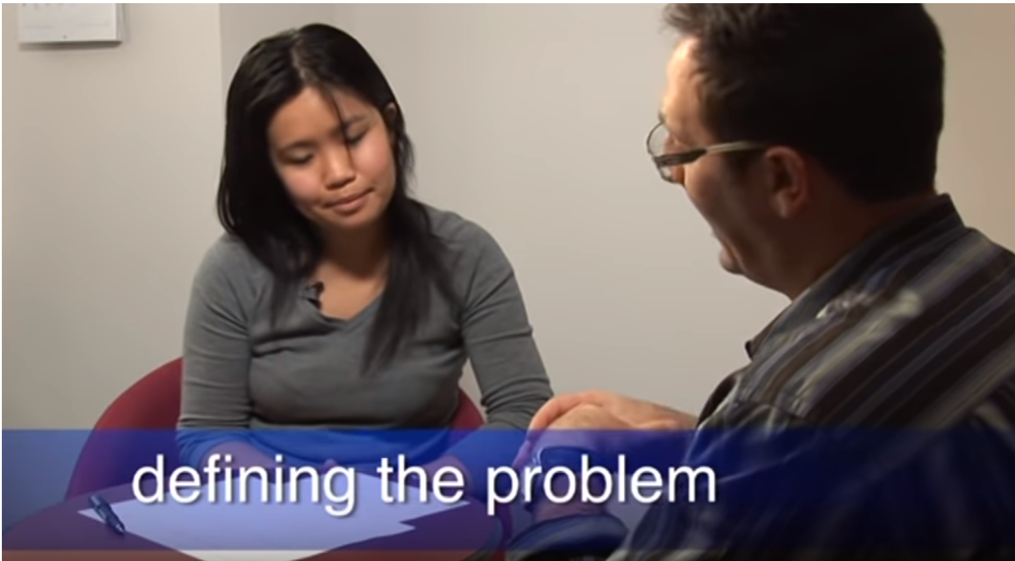
https://youtu.be/iCoPbbLQ5m4

Topic & time | Activity description and facilitator guide | Resources
Structured Problem Solving  Activity  (Allow 15 mins) | Describe structured problem solving including the following key messages:  - structured problem solving is a proven approach that many people have found helpful for working through difficult problems.  - Structured problem solving (SPS) is a skill you can learn that helps you to step back and look at your problems, in a clearer, more structured way.  - It’s a “thinking skill” that can help you take control of your problems and gives you a roadmap to work through them.  - Structured problem solving can be done on your own, with someone else or as a small group. The aim is to clearly define the problem and then work together to generate ideas and solutions.  - This is one of the most useful self-management skills that you can teach your patients.  Activity –  - Ask the group to work in pairs  - Give each person a set of problem-solving handouts  - Ask the participants to choose a problem that they would like to work through  - Using the ‘problem solving’ work sheet, take five minutes each to work through their problem, then swap  - Follow the process through to step 4  Facilitator leads a discussion about how the technique could be used in practice. | Problem solving pages from Take Charge  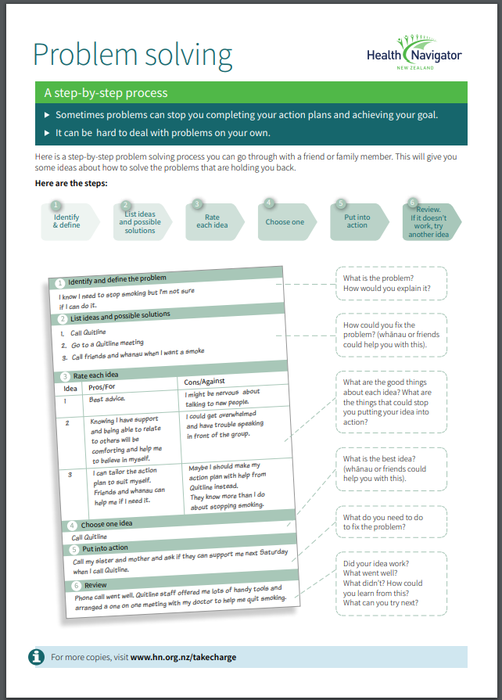  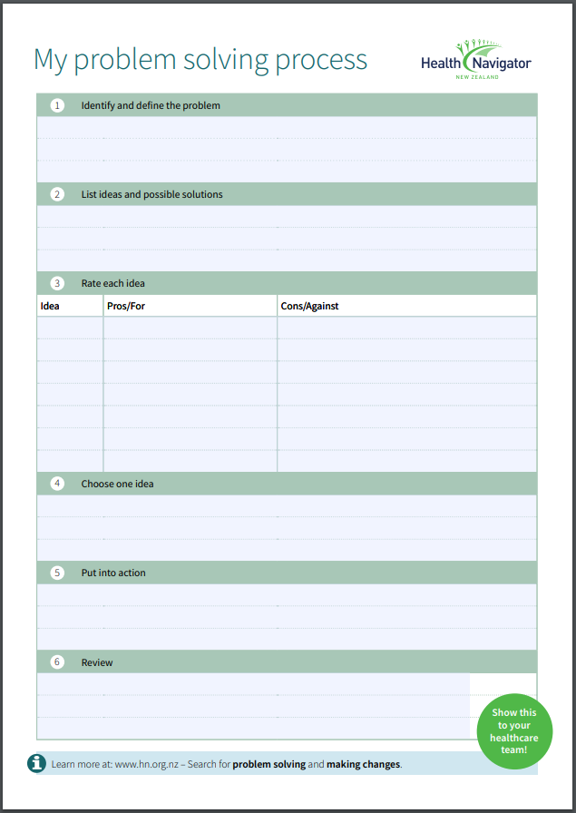

Handout: https://www.healthnavigator.org.nz/media/7650/problem-solving-17may19-interactive.pdf
For additional modules, visit: add url

