Handout: Goal Setting and Action Planning

Goals and Action Plans

Goals
A goal must be something that the person wants to achieve. If the goal is something that really matters to that person then they are more likely to achieve it because the person is more motivated to make the changes needed.
A person may have several goals. These goals might be a mixture of health, personal and social issues. Keep them simple and try to focus on the one or two things that are most important to the person.
Goal setting
Goal setting is one of the most important skills in helping people make changes.
Advantages of a goal setting approach to making healthcare decisions:
- Goal setting frames the discussion in terms of what the person wants to do rather than what healthcare staff might think the person should do.
- Goal setting makes decision making easier for people with multiple LTCs by focussing on outcomes that go across conditions and aligning treatments towards common goals
- Goal oriented plans help people and their healthcare team, to discuss which is important to the person and decide on priorities based on what the person can achieve in relation to what is important.
- When the person’s priorities are known, the person can collaborate with their healthcare team to work out steps to be taken towards achieving their goals and how progress can be monitored.
Action Plans
Action plans are about changing behaviour. When helping someone develop an action plan it is important to target the behaviour rather than the outcome. For example, walking or not eating between meals (behaviours) rather than weight loss (outcome).

An action plan should have a goal and a brief description of why they want to do it and how it will help achieve the overall goal. A person should select one behaviour to work on at a time and it should be something that they want to do.
When working with someone to develop an action plan it is important to assess how important the action plan is to them, and how confident they are in achieving the action plan.

Patient goals compared to Clinician goals

Tick the column if you think each goal is a patient goal or a clinician goal?
Goal | Patient goal | Clinician goal
- “I will walk for 30 minutes 5 x per week”
- “I will go to the library and attend the internet classes once a week so I can learn how to skype with my grandchildren.”
- “I will get my HbA1C down from 84 to 70 by date…”
- “Quit smoking and lose 5% body weight.”
- “Take all your medicines as prescribed.”
- “I will take my asthma preventer at least 6 mornings a week and mark it on the calendar to help me remember.”

The difference between behavioural goals and outcome goals

- Behavioural goals – these are developed to focus on a change in behaviour. The behavioural goal must be something that the person wants to do and take into account what is important to the person. Ideally the behavioural goal statement should contain the motivation for change e.g. “I will go to the library and attend the internet classes once a week so I can learn how to skype with my grandchildren.”. A person should only be working towards one behavioural goal at a time and that goal should be simple and easily achievable in the first instance
- Outcome goals –Outcome goals seem like they might have come from the health care team e.g. reduction in blood pressure, weight, HbA1c etc. Outcome goals are generally achieved as a result of a change in behaviour, but the behaviour is not explicitly stated. For example, a reduction in blood pressure (outcome) may happen because the person does exercises regularly (behaviour) but this is not stated. .

Assessing Importance and Confidence with the ‘change ruler’

You use a change ruler once the person has got to the stage where they want to make change.
Imagine a scale of 1-10, where 1 is not important and 10 is very important
1 | 2 | 3 | 4 | 5 | 6 | 7 | 8 | 9 | 10

You use the change ruler in two ways:

1. To assess the importance to the person of making changes to achieve their goals. Ask them:
“So, on a scale of 1-10, how important is it to you to make changes to achieve your goal?”
And when they answer then you ask a 'backwards' question "So why are you at a 5 and not a 1?" When you are talking about importance you need to go backwards so the person then tells you the reasons WHY they need to make a change. Remember, this is called ‘change talk’.
If you ask people a 'forward' question "Why are you at a 5 and not a 7?" then the people will give you all the reasons to stay the same and not make any changes. This is called ‘sustain talk’ – the opposite of ‘change talk’.
2. To assess the person’s confidence in making changes so they achieve their goal. Ask "So, on a scale of 1-10 how confident are you that you can make the changes to achieve your goal?” The person’s confidence levels really need to be at a 7 as an indication that they have the ability to make the changes. So, if they are under 7 ask a 'forward' question "What would it take for you to be a 7?" Don’t force the person to increase their confidence to a 7. Instead make the action plan/goal smaller or break it down more e.g. “go to bed at 10pm 3 nights a week” rather than 5 nights a week. Or “sleep 8 hours at night for 3 days” rather than go straight to 9 hours per day.

Goal and Action Plan Case Study

Joyce age 69, diabetes and painful leg ulcer
What matters to me – get back to looking after my grandchildren
Goal -pick up my grandchildren after school two days a week from the start of next term so I can see my grandchildren regularly and feel like I'm doing something useful (motivation to change behaviour).
How will this help
Things I could do –make changes to what I eat, walk more, stop smoking, do dressings, take medicines, check blood sugars.
My Action Plan
What – walking
How much or how often will I do this – walk to the dairy and back twice a week
When - on Tuesday and Thursday after breakfast
Who will help – my neighbour will walk with me until I get confident
How confident am I that I can do this? 7
Other things I will do to help and ask my healthcare team about – do my dressings as described, take my medicines as prescribed, check my blood glucose before breakfast after lunch and before bed for the next week
Things I am not ready to do yet to give up smoking or change what I eat

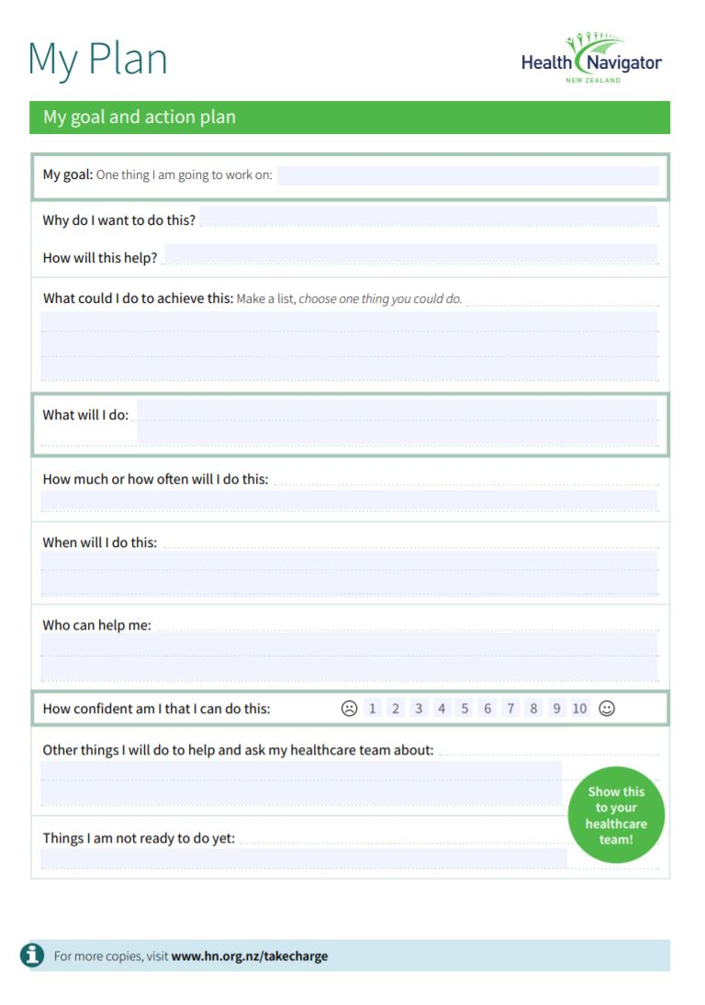

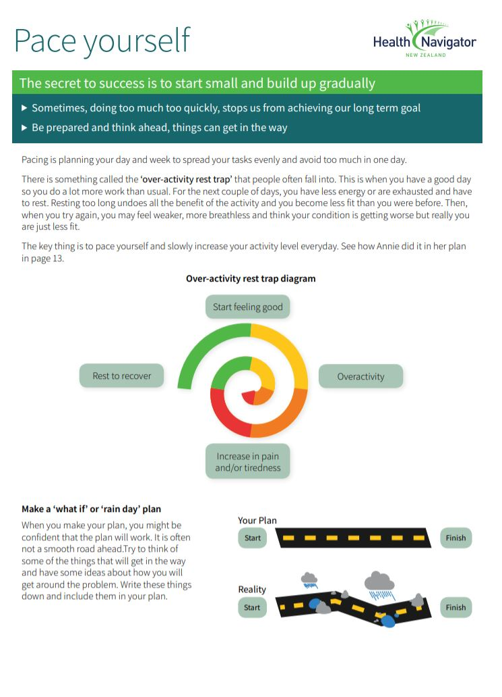

More case studies

Harry
Harry has Type 2 diabetes and lives alone with his dog Spot.
Harry has not been looking after himself properly since his wife died.
His diabetes is poorly controlled, and he has an ulcer on his leg that is not healing.
Spot is Harry’s main companion but Harry is now struggling to look after Spot and take him for walks. Harry can’t let Spot out to run in the back yard as there is a hole in the fence that Harry can’t fix by himself. Harry used to enjoy doing things like that.
It is really important to Harry that Spot keeps on living with him.

Annie
Annie has high cholesterol and has just been told that she has pre-diabetes and is at risk of developing Type 2 diabetes. Annie’s mother and sister both have Type 2 diabetes and are on insulin and Annie does not want this to happen to her.
Annie lives with her husband in the family home. Annie’s children are now adults and no longer live at home. Annie’s eldest daughter lives in Australia and is getting married in 6 months’ time.
Annie works in an office and catches the bus to work even though work is not very far away from her home. Annie enjoys gardening, has grown her own vegetables in the past and used to go dancing with a friend.
Annie has been told by her doctor that if she loses weight she will reduce the risk of developing diabetes.

Use one of the case studies to complete the form on the next page

Be ready to explain
- The goal – what do you think is most important or what matters most to the person in your case study
- how the goal will help
- Brainstorm things the person could do (behaviours) for the action plan
- Why you chose one behaviour for the action plan
- How you worked out how much/often, when
- Who can help (how can you help to build a support team for this person, any referral to community/other supports/resources)
- How you assessed confidence based on the case study
- The other things they will do
- The things that the person is not yet ready to do yet
- Pacing and avoiding over activity and the person’s ‘what if /rain day’ plan

