Handout: Problem solving and decision making

Problem-solving
People with LTCs will often have problems that can stop them completing actions plans and achieving their goals. People can find it hard to deal with problems on their own and might ask you to help them solve a problem.
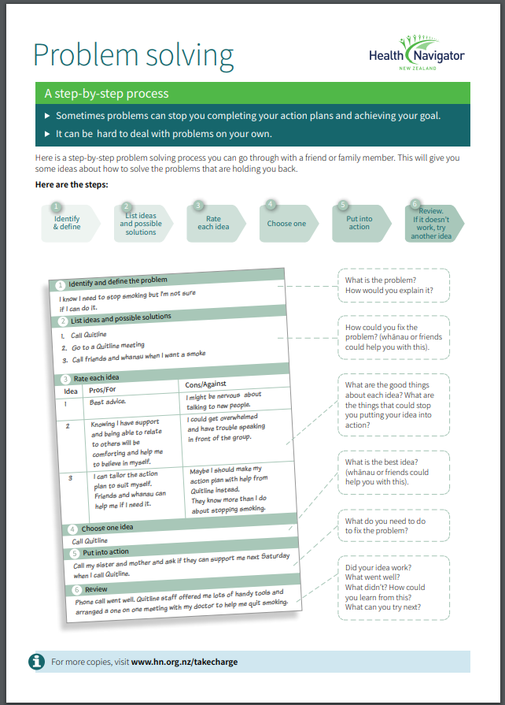
Sometimes problems cannot be solved, and you might need to talk to the person you are working with about that.
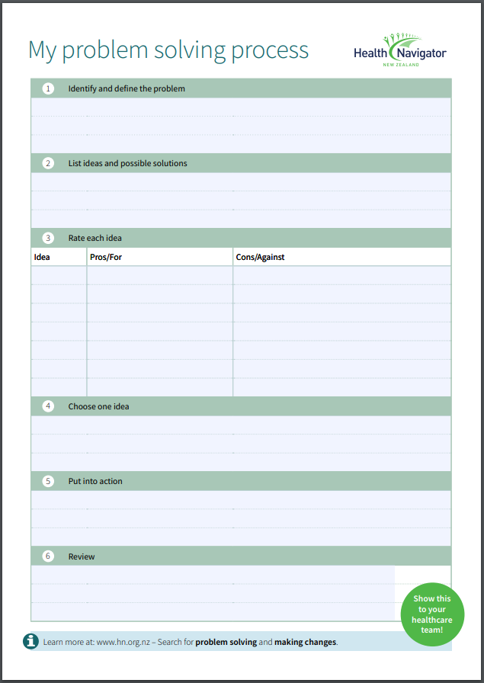

Decision-making
People with LTCs have to make decisions all the time about their health. And often they are making those decisions at a time when they are not feeling very well. You can help them make a decision using steps that are similar to the problem-solving steps.

Step 1. Work out the different options.

Step 2. Write down the pros (good things about the option) and cons (not so good things about the option).

Step 3. Score each pro and con from 1 (not important to the person) to 5 (very important to the person).

Step 4. Add up all the scores for the pros and cons to find which side has the highest score.

Step 5. Before the person goes ahead with the side with the highest score, ask the person does it feel right for them. If the person says yes, then they should go with that decision.
Example
One of the people you are working with currently has fish and chips every Thursday night for dinner. You have been encouraging him to eat more healthy food and he is trying to decide if he could have fish and chips once a fortnight instead of every week.
Decision - Should I start eating fish and chips once a fortnight instead of once a week?
Pros | Score | Cons | Score
It is much healthier | 3 | I will miss it | 4
It will help with my cholesterol | 3 | I will have to cook something else for dinner | 3
It will help with my diabetes | 4 | The fish is good for me | 2
It will help me lose weight | 2 | It is quick | 4
It will save some money | 1
It will be better for the whānau | 3
Total | 16 | Total | 13
Based on this, the decision would be to have fish and chips once a fortnight. Remember to check with the person that the decision feels right for them and they are confident to make this change
Decision…………………………………………………………………………………………………………………………………
Pros | Score | Cons | Score
Total |  | Total

